Cloud-base Referral Management System

Proposal

by
Chris Wong
Rx

Version | Date | By | Description
V0.1 | 2020/9/23 | Chris Wong | First draft
V0.2 | 2020/10/8 | Chris Wong | Revised User Requirement
V0.3 | 2020/10/16 | Joe Tong | Revised Project Schedule
V0.4 | 2020/10/18 | Chris Wong | Updated Flows Diagrams
V0.5 | 2020/10/22 | Wegman Tam | Standardize names in the document  Development Environment confirmed and updated  Updated Flows Diagrams :  Referer Flow (add view and add message function under Job history)  Sales Admin Flow (add create Sales function)  Customer Service Administration – 1. add industry and supplier maintenance function , 2. change “CS & Sales” block to “CS, Sales Admin and Sales”, 3. under Job Management, specify “add message” function, 4. Specify point allocation ratio modification function (e.g. 7:2:1)  Data Table confirmed and added
V0.6 | 2020/10/27 | Wegman Tam | Further clarify Development Environment  As requested by Ryan,  Modify Referral Info, remove Company Name, Company Address, Job Description & Contact info.  7. 工单跟进 (留言)：中 “Sales和Referrer不可以看到彼此的留言” 這一句刪除 => “Sales和Referrer可以看到彼此的留言”  2. 用戶登錄中 將“其中注册个人信息包括：用户名，密码，真实姓名，电话，EMAIL，地址” 這一句刪除
v0.7 | 2020/10/30 | Wegman Tam | Extend Bug fix period after system go-live to 6 months  Customer Service Admin block, add “Sales Admin” role

Table of Contents

1. Introduction 5
2. Background 5
3. System Design and Approach 14
4. Intellectual property (IP) 16
5. Project Scope 16
6. Project Governance and Control 21
7. Assumptions 24
8. Estimate Schedule 25
9. Cost 27

Introduction

This document intents to provide the documentation on the software design for customized User Interface of Sinicone Ltd.’s Cloud-base Referral Management System before commencing the real code programming. It is expected to reach a mutual understanding in the user expectation towards the final integration to Cloud-base Referral Management System.

Background

Cloud-base Referral Management System is one off software development service from Sinicone Ltd. The system consists of front-end user Interface for Referrers Sales Admin and Sales web console, Customer Service Admin and Customer Service web console and Points System. The backend system consists of Web Server, Application Server and Database. Firewall to be placed to separate the frontend Web Server and the backend Application Server and Database. The system to be developed in two phases, where phase 1 mainly on basic functions to allow business run as usual, and the phase 2 to enhance Mobile Application and Point System.

System Overview
The system is hosted at a cloud platform. It contains an IIS Web Server, Application Server and a Database. IIS Web server provides a web interface for system administration. Application server manages mobile apps, Point System and store communication data between sales and referrer.

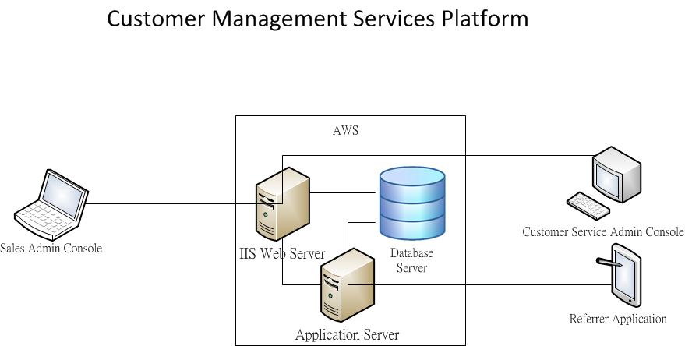

System workflow:
Referral Management System can let referrer to submit Order Form via mobile apps with multiple job orders to database. Sales Admin will distribute those jobs to Sales Rep. for fulfillment. Once job being fulfilled Points to be created to referrer. Customer Service Admin and Customer Service Agent will keep track of those job fulfillment status and will step in for further action if the job unable to complete by 12 hours. Customer Service Admin also handle Referrer, Sales Admin, Sales, and Customer Service agent registration and operate the Point System and able to admission and statically reports on web portal

Referrer Flow

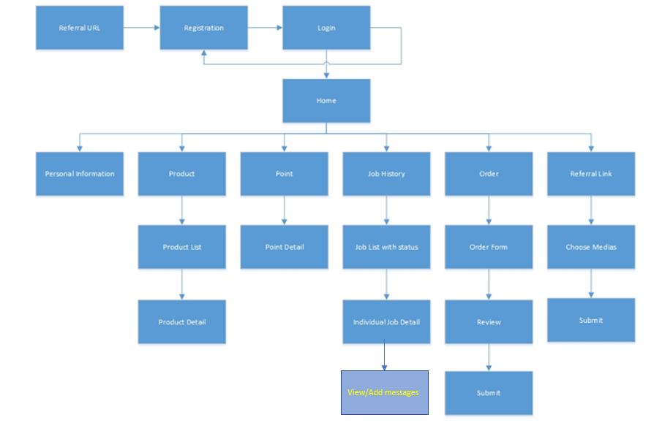
Sales Admin Flow 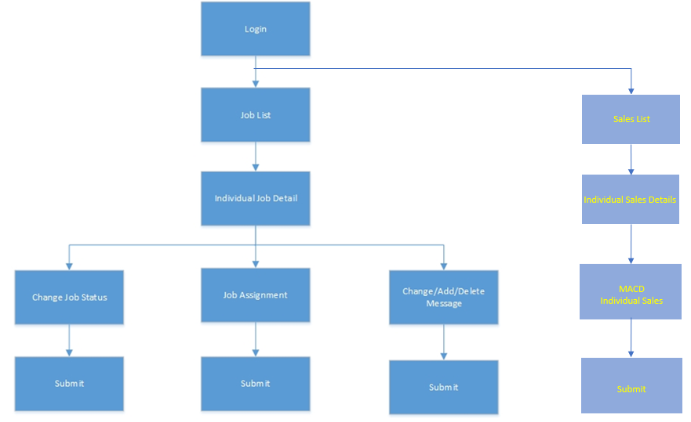
Sales Flow 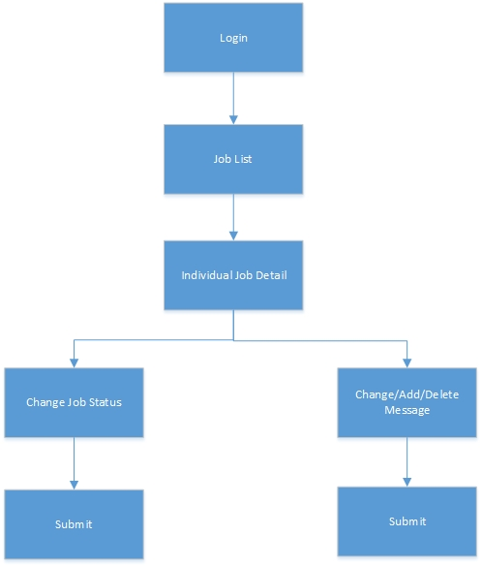

Customer Service Administration

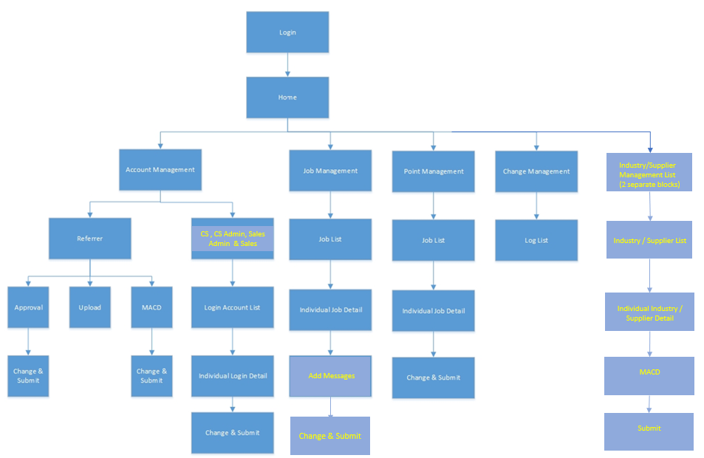
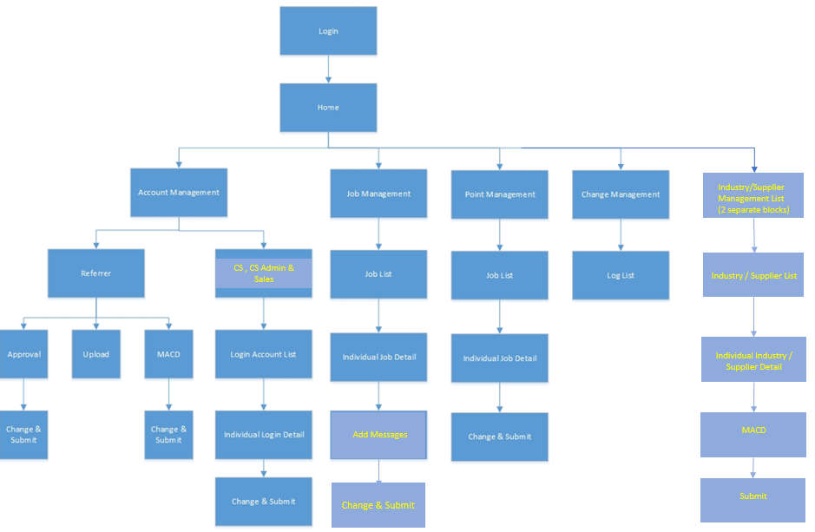
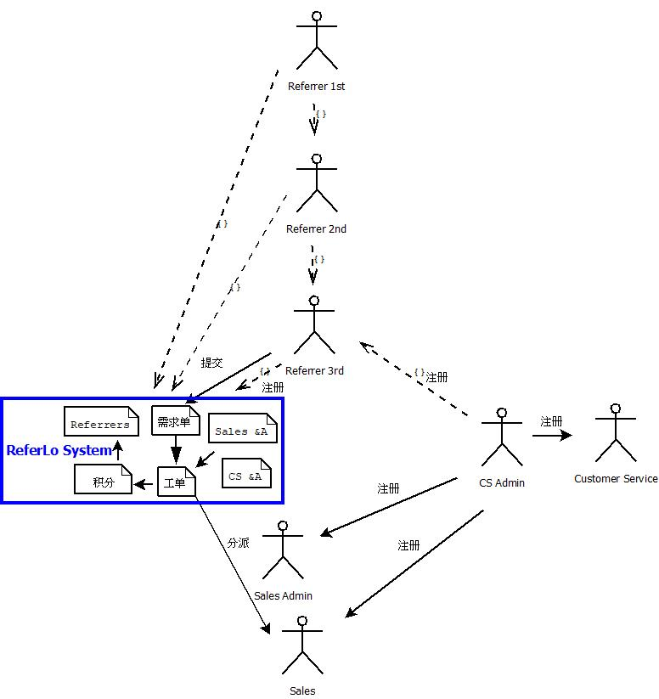

Referrer mobile apps.:
The mobile App is the application allows referrer to submit multiple job orders to system. And fulfill self-registration to the system
Referrer input information:
- ReferrerID
- Upper Referral ID
- User Name - This will be used when CS call the referrer.
- Date
- Status (non-display field for referrer)

- Phone number
- Email

Product List
Product list should be an input form with the following fields
- Supplier ID (from Supplier Master. Pull down menu)
- Suppliers name (display field, as defined by the Supplier ID e.g. PCCW) )
- Product name (e.g. Commercial Telephone line or Commercial ISP)
- Default points (total points available for 3-level share)
- Industry (from another list industry Industry masterMaster. Pull down menu)
- Default points Points limitLimit (defined by industry, default points should not exceed this Default points limit)
- Remark (Free text, Max. 1000 characters)
- Attachment (optional) for pictures catalogue etc. (Max. # of attachments - 3, Max size for each doc - 2M)
- Status: “A”-active, “S”-suspended (not selectable in order)

Industry master list
- Ind ID – System generated (4 digits sequential)
- Industry name
- Points limit (type: integer) - this value will be looked up for default point limit in Product List)
Supplier Master List
- Supplier ID – System generated (4 digits sequential) – this will be looked up from Product List
- Supplier Name

Point Allocation Master - default allocation as in table below:

Level 1 (refer to the one who submits the order form) | 70% of points
Level 2 (the 1st upper referrer) | 20% of points
Level 3 (the 2nd upper referrer) | 10% of points

Development Environment:
1) Application Service – Windows .Net Core
2) Database – PostgreSQL
3) Frontend – Vue Framework
4) Android/IOS – flutter
5) API – REST API

System Design and Approach

System Set up Approach:
- Build and design referrer management system and understand their actual operation.
- Complete User Interface, mobile app system integration and CMS admin page design before actual coding.
- Sinicone Ltd will install and intergrade the system for AMSL
- In the implementation stage, we will use Sinicone’s cloud service for all the coding, testing and UAT.
- Testing stage will flow implementation, internal testing, customer UAT and then production.
- This phase only provides mobile apps for Hong Kong region with local currency.

Required Input
Information to be collected before actual programming:
- Confirm Cloud platform provider, server size and capacity requirement
- Service Level for onsite support
- Hardware and system architecture
Assumptions, Risks and Issues
- This proposal is based on the high-level requirement collection in the customer place, the schedule and costing may be impacted if there have any change in the scope or requirement.
- Server performance would be depending on cloud service provider performance, mobile carrier performance and consumer internet speed/bandwidth on mobile, SinicOne Ltd is not liability for any performance issue.
- Customer must provide contents, voice/data plans, payment gateway accounts
- Customer must gain authorization from mobile carrier for Air-SIM management system integration, SinicOne Ltd is not liability if customer can not gain access from mobile carrier for access to mobile carrier system.
- All testing mobile devices shall be provided by customer.

Intellectual property (IP)

SinicOne Ltd will NOT transfer Intellectual property (IP) rights to “Customer”. IP refers to creations of the intellect for which no limits to actual program code (including whatever source code has been added to the original code), trademarks, copyright, patents, industrial design rights, and in some jurisdictions trade secrets, artistic works where may include music and literature, as well as discoveries, inventions, words, phrases, symbols, and designs associated with this game. However, SinicOne Ltd will not resale this code or any Intellectual property (IP) rights to third party.

Project Scope

The project includes 12 deliverables from AMSL :
Roles:
- Referrer (Level 1), Referrer (Level 2), Referrer (Level 3)
- Sales Admin, Sales
- Customer Service Admin, Customer Service

系统流程：
- 用户注册：
- Referrers Account可以自己在APP（目前只有APP，将来可以通过网页操作）注册或者由Customer Service Admin或Customer Service在系统中创建，此类注册的Referrer Account缺省为第一层级 ，或者由其他Referrer推荐自己进行注册。Referrer此类的用户注册需要进行EMAIL验证。
- Customer Service Account，Sales Admin Account, Sales Account全部由Customer Service Admin注册生成用户账户
- Sales Admin Account 可以创建Sales Account
- Referrer注册时候要选择同意T&C方可创建

- 用户登录：
- Referrer登录系统后可以随时查看过去提交需求单和由需求单产生的工单状态，显示已有的积分，可以进行个人信息和密码的变更修改。注册后具有可以发送链接给其他人的功能。
- Referrer APP可以收到系统推送的信息
- Customer Service Admin, Customer Service登录后可以查看和修改任何需求单及工单的状态，可以给Referrer、Sales 留言或者回复他们的留言。
- Customer Service Admin 登录后系统可以创建其他各类用户账号, 可以查看和修改任何需求单及工单的状态
- Sales Admin 登录系统后可以查看任何需求单、工单的信息，并可以分派工单给不同的Sales

- 基础资料输入：
- 由Sales在系统中输入包括：
- 产品或服务的种类和相应的积分
- 各种产品（或者服务）工单签约完成后不同层级Referrer获取积分的规则
- 由Customer Service 设定工单超时提醒时间

- Referrer推荐：每个Referrer 登录系统后都可以通过EMAIL发送一个链接给其他人，收到链接的人可以点击链接到系统进行注册，成功注册则Send链接的人（Referrer）自动成为上一层级，系统共分三个层级Referrer （见上图所示）

- 需求单提交：
Referrer登录系统后，可以在系统提交需求单，可以是多项产品（或服务）需求信息，提交后需求单的状态为Received。需求单只有提交人、Sales Admin 、Customer Service Admin和Customer Service可以看到。

- 需求单内容包括：
ReferrerID，Referrer Name，创建日期，需求单状态，联系人姓名，公司名称，公司地址，电话，EMAIL，需求信息

- 需求单有以下几种状态:
- Received
- Following
- Signed
- Completed
- Reject

- 工单生成
系统根据需求单中的每一个产品（或服务）需求项目自动生成单一的工单，此工单初始只有Sales Admin、Customer Service Admin、Customer Service和提交此需求单的Referrer可以看到。经过由Sales Admin分派工单给不同的Sales做跟进，分派后被指定的Sales才可以看到此工单，其他Sales不可以看到。

工单有以下几种状态:
- Received
- Following
- Signed
- Completed
- Reject

工单内容包括：
ID，Referrer Name, 工单创建日期，工单状态，联系人姓名，公司名称，公司地址，电话，Email，需求信息，Sales Name

- 工单跟进 (留言)：
工单生成之后，在系统中Referrer和Sales都可以对每个工单进行留言，留言只有Customer Service Admin, Customer Service, Sales Admin可以看到双方的留言，Customer Service，Customer Service Admin 可以给双方留言及回复留言，Sales和Referrer可以看到彼此的留言。

Sales Admin，Sales, Customer Service Admin 和Customer Service都可以改变工单的状态，系统根据工单的状态同步更新需求单的状态。

提醒功能：系统对Received状态下超时无反应的工单向Customer Service Admin和 Customer Service发出提醒通知

- 获取积分
当Sales 线下签完订单之后在系统中需改变工单的状态为Completed，Customer Service 对所有工单为Completed工单进行再次确认，确认后系统会根据设定的积分规则为每一层级Referrer生成积分, 如果无积分规则的项目缺省显示“积分暂未公布”，之后适当时候由Sales 手动输入相应积分，如有不同层级则同样按照设定的固定规则分派积分. 如果某个时间积分或者规则发生变更，对变化之前的工单没有影响，只对变化之后生成的工单发生影响。

所有对积分的操作最终都需要经过Customer Service Admin批准方可生效，生效前Referrer不可见到积分

- 积分历史记录查询功能
- 需求单查询与搜索功能
- 工单查询与搜索功能

- 业务规则：
- Customer Service Admin, Customer Service, Sales Admin 和Sales有权限更改任何工单和需求单的状态。
- Customer Service Admin 可以设定产品或服务的积分
- 只要工单完成，如果存在多层级Referrer，则每个层级的Referrer都会按照设定的规则获得积分
- 手动填写的积分有最大积分规则约束
- 任何产品或服务的固定积分设定、手动输入的积分的生效、积分对各层级Referrer的分配规则设定和Referrer最终获得积分都必须要经过Customer Service Admin批准
- 需求单只有Referrer本人、Sales Admin、Customer Service Admin和Customer Service可以看到，其他上层级Referrer可以看到下层级Referrer有需求单和需求单的状态，但是不可以看到需求单的内容
- 工单只有被指派的Sales和 Sales Admin，Customer Service Admin, Customer Service以及提交需求Referrer可以看到，其他Sales不可以看到
- 工单中的项目签约全部为线下完成
- 系统初始缺省用户为Customer Service Admin，具有最高权限

Maintenance
I. Only for bug fix if not subscribe maintenance service
II. Provide 6 months Bug fix period after system go-live
III. Not support any new add feature or system modification after confirmed the scope of work (get signature from customer when confirm the scope before coding)

System Support (Optional)
- SinicOne Ltd shall provide 8x5 phone support.
- SinicOne Ltd shall provide 8x5 maintenance support.
- LOA required to authorize SinicOne for supporting cloud service
- Provide admin or root account to SinicOne for supporting cloud platform

Project Governance and Control

Methodology
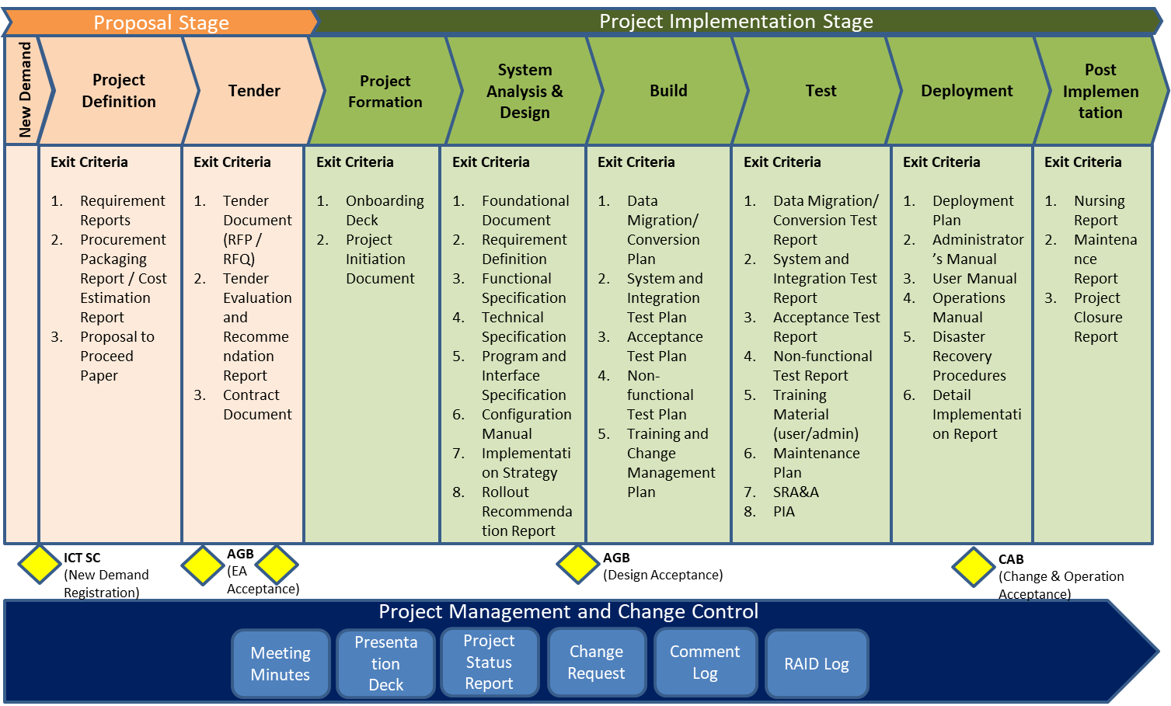
A part from the system development life cycle, in order to facilities the overall project governance and control, in this project, the change control methodology.
Meeting minutes/Meeting Notes
For each of the PjMT and PjSC meeting, a meeting minutes/notes to be used to records the essence of the meeting, including details such as: decisions made (motions made, votes, etc.), next steps planned, identification and tracking of action items. It also act as a tangible record of the meeting for its participants and a source of information for members who were unable to attend or as a reference point for collaborative activities. This meeting minutes/notes will be release within 3 business days.
Presentation Deck
Presentation Deck are used in the PjSC meeting to present the overall project status, progress and key system functions. The deck should be ready 2 days before the meeting
Project status report
A project status report will be conduct before the PjMT meeting and will report within the meeting to reflect the overall project progress.
Change request
Change request document will be submit within the PjMT and endorse by the PjSC.
Comment log
A comment log will be taken for the first release of the meeting minutes and document review.
RAID log
A RAID log will be review within the PjMT meeting.
Role and Responsibility for the Project
Project Steering Committee (PjSC)
Role | Responsibility
AMSL | - Provide direction and guidance on project implementation, business policies, business process standardization and business changes  - Review and approve project scope, objectives, and project plan and any change request in project scope, cost and schedule  - Monitor project progress and resolve major project issues related to scope, schedule, resources, budget and contract escalated by PjMT on a timely basis
SinicOne Ltd | - Provide required resources and facilities to the project  - Ensure the products of the project meet customer quality expectation and acceptance criteria

Project Management Team (PjMT)
Role | Responsibility
AMSL IT | - As the single-point-of-contact (SPOC) representing AMSL in PjMT  - Identify impacted AMSL teams (internal and subcontractors), collect requirements from them, and take the lead to resolve conflicts  - Define and confirm requirements (functional, non-functional, technical), prepare the to-be process design, and review relevant deliverables for endorsement  - Define project schedule, participate in testing, training and report the progress to PjSC in a monthly basis  - Follow up day-to-day project activities and resolve issues in a timely manner and escalate to PjSC when necessary
AMSL Business Owner | - As the single-point-of-contact (SPOC) representing business users in PjMT  - Identify impacted business teams (internal and subcontractors), collect requirements from them, and take the lead to resolve conflicts  - Act as change coordinator among business departments  - Define and confirm requirements (functional, non-functional, technical), prepare the to-be process design, and review relevant deliverables for endorsement  - Recommend and define the project priority, phasing and functional roll-out based on the business and operation priority  - Sign-off deliverables from each major project milestones and Go/No-Go assessment for Go-Live  - Report issues and risks and make escalation PjSC
SinicOne Ltd  Project Management  and Implementation | - Manage the project within scope, timeline and budget  - Own and oversight of the project progress  - Maintain and control project plan  - Track and manage the resolution of project issues and risks  - Perform Quality Assurance of project deliverables  - Plan project activities and work packages for Vendor Implementation Team  - Coordinate the review process with PjMT  - Coordinate the logistic for meetings with PjMT and PjSC  - Ensure smooth handover of system to AMSL  - Drive the project progress weekly meeting and activities  - Perform Weekly Reporting of Project Progress status  - Deliver relevant deliverables for endorsement

Change Control
While project team members try to keep project scope stable to avoid impacting project schedule or cost, a set of Change Control rules should be setup and followed by in case of any scope change. The Change Request process is as of follow:

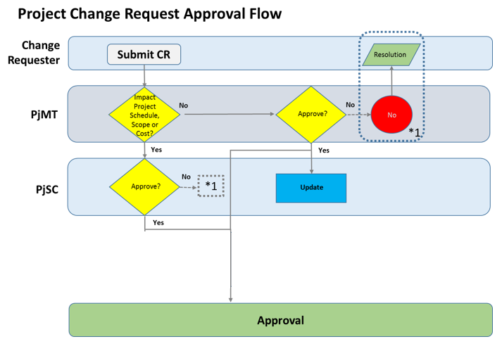

Assumptions

The Customer shall assign a project manager to be the focal contact to SinicOne responsible for all matters related to the Proposed Service.
The Customer Project Manager shall take the role of Customer’s management representative in the project committee for the Proposed Service and shall have the authority to make final and binding decisions on behalf of the Customer including but not limited to:
To provide management directions, guidance, decisions and approvals required to maintain project momentum;
To provide information and resources needed in a timely manner for SinicOne to complete the service tasks as described in this proposal;

To be readily available onsite and reachable as and when required by SinicOne during the whole duration of the project;
To resolve issues, change control and make escalation for the Customer on matters related to the Proposed Service within a reasonable turn-around time in observation of the Project Schedule;
To be responsible and to have the full authority on behalf of the Customer to receive and sign-off, within a reasonable, or any pre-defined time limits, the deliverables submitted to the Customer as a result of the Proposed Service.
The Customer shall identify the personnel in its organization that are relevant to the delivery of the Proposed Service, and assign these individuals to the necessary roles to facilitate the service delivery.
The Customer shall ensure that all information (including but not limited to service requirements, designs, topologies, diagrams, etc.) are up-to-date and valid for SinicOne to perform and deliver the Proposed Service.
The Customer shall provide user accounts and/or access permission, free of charge, to information and systems that are relevant and necessary for SinicOne to perform the service tasks of the Proposed Service. The Customer shall provide written notifications to SinicOne on any precaution and/or restriction that SinicOne and its assigned personnel should observe in the use of such user accounts and access permission.
The Customer shall provide physical access, free of charge, to any locations that are necessary for SinicOne to access to perform the service tasks of the Proposed Service.
The Customer shall provide all cables and cross connect cables in Customer’s data centers or communication rooms if necessary.

Estimate Schedule

 | Week 1-2 | Week 3-4 | Week 5-7 | Week 8
Requirement Collection | √
Cloud Platform | √ | √ | √
System Coding |  | √ | √
System Testing |  |  |  | √
Migration |  |  |  | √

Cost

TBA

